Exercise 1 (Average Monthly Temp)

Radar ChartBar Chart

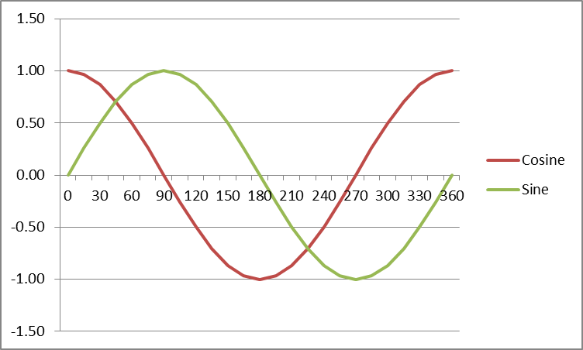Exercise 2

